Crop Disease Detection and Diagnosis System

|  |  |  |
| --- | --- | --- |
|  |  | |
| **Aayush Singh**  *Department of Computer Engineering* | **Deepanshu Sonparote**  *Department of Computer Engineering* | **Nitish Talekar**  *Department of Computer Engineering* |
| *Rajiv Gandhi Institute of Technology*  ***aayushipsingh@gmail.com*** | *Rajiv Gandhi Institute of Technology*  ***deepanshusonparote@gmail.com*** | *Rajiv Gandhi Institute of Technology*  ***nitishtalekar.nt503@gmail.com*** |

***Abstract* - The crop agriculture industry faces the economic losses due to the pest infections, bacterial or viral contagions, the farmers lose nearly 10-20% of the total profit on an average annually in India. This paper proposes a solution to the agricultural problem, which involves crop disease recognition by using machine learning and deep learning techniques. In this paper, the study sets out to classify cotton crop images into classes, whether the crop is infected by a disease or not. Also, we endeavour applications that give the farmer readily available means to identify the diseases on their crop and take appropriate damage control actions. The dataset used to train the model was user created (mobile capture images with high-resolution camera) from various crop farms. Cotton crops, of different varieties, containing four classes of diseases, namely Rust, Mosaic Virus, Woolyaphids and Healthy plants are taken as classification ideals. The trained models have provided a performance reaching a 79.53% success rate in identifying the corresponding cotton plant disease. The model used in the study delivers significant accuracies of classification on the dataset used by employing Dense Neural Network techniques. The model is very useful advisory or early warning tool for the farmers for identification of diseases in the early stage so that immediate action can be taken.**

***Keywords – Crop Disease Detection, Cotton plant leaf, Dense Neural Network, Image processing*.**

I. Introduction

Agriculture is the primary occupation in India. Crops are part and parcel of the agricultural industry. Nowadays, a tremendous loss in the quality and quantity of crop yield is observed, subject to various diseases in the plant. Crop Plant disease classification is a critical step, which can be useful in early detection of pest, insects, disease control, increase in productivity, among other examples. Farmers recognize disease manually with foregoing symptoms of plants, and with experts, whereas the actual diseases are hard to distinguish with naked eye, and it is time-consuming to predict whether the crop is healthy or not. Cotton is one of the major agricultural crops in India and it has a dominant impact on the overall Indian agriculture sector. Cotton plant leaf disease diagnosis is very difficult through observation to find the symptoms on plant leaves, incorporates it's a part of a high degree of complexity. Due to complexity, even experienced agronomists and plant pathologists often fail to successfully diagnose specific diseases and are consequently led to mistaken conclusions and treatments.

Our study helps to predict crop diseases in cotton plants by processing the images of the crop. For this, Image Processing techniques are used for the very fast, accurate and appropriate classification of diseases. Symptoms of diseases in cotton predominantly come out on leaves of plants. The existence of an automated system for the detection and diagnosis of plant diseases would offer a support system to the agronomist who is performing such diagnosis through observation of the leaves of infected plants.

The existing techniques for disease detection have utilized various image processing methods followed by various classification techniques. Crop Yield Forecasting has been an area of interest for producers, agricultural-related organizations. Timely and accurate crop yield forecasts are essential for crop production. The proposed system uses an artificial neural network to classify the health of a cotton leaf plant. The flow diagram of the proposed system given in Fig. 1. consists of steps used to acquire the desired output.

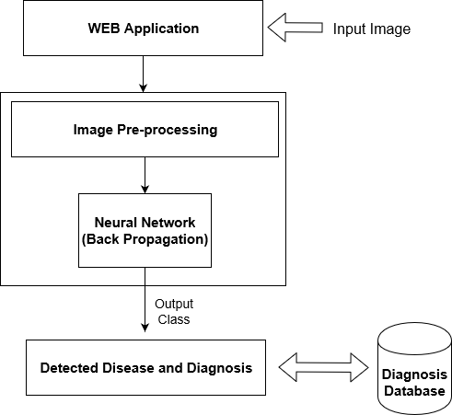

*Fig 1. Flow Diagram of Proposed System*

II. Methodology

*A. Input images*

For this initial process images of high resolution (4160 x 3120) are taken from datasets as input by setting IMG_W, IMG_H with 3 channels (RGB), for better visibility, go with > 180. The features that are used for classification of the images. The images are foremost pre-processed into a 4160x 3120, RGB format with pixel values ranging from 0 to 255. The feature normalization used in the study is the min-max normalization. It is the ratio of the difference between the instance's feature value and the minimum value of a feature in the instance to the difference between the maximum and minimum values of features in the instance.

*B. Training and Testing*

The tensor flow framework is used for training and testing. The model which is employed is the DNN Classifier. The DNN Classifier which is created has a seven-layer neural network. The activation function used is ReLU which is used for each of the hidden layers and the SoftMax function used in the last layer. Gradient descent optimizer is used for optimization. The dataset is divided into a train test split of 70-30%. compare the result and errors back-propagated.

*C. Feature Extraction*

The DNN classifier used was fed with features (pixels of image instances). DNN classifier is used with 5 hidden units with 100 nodes each and a 6th hidden unit with 50 nodes. The images were pre-processed through resizing. The images with given height, width and channels are fed to the DNN. ReLU (Rectified Linear Unit) activation function was used.

*D. Dataset and their labels.*

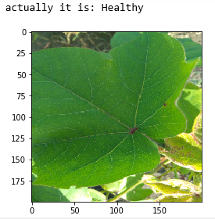 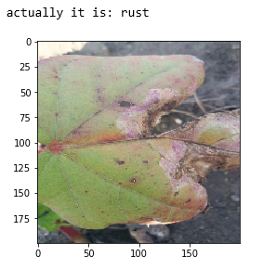

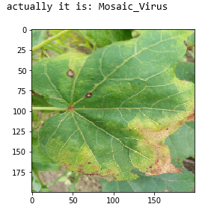 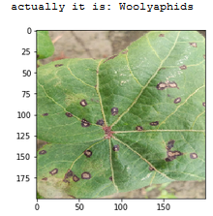

*Fig 2. Dataset Examples and their labels*

III. Literature Review

Crop Yield Forecasting has been an area of interest for producers, agricultural-related organizations. Timely and accurate crop yield forecasts are essential for crop production. The existing techniques for disease detection have utilized various image processing methods followed by various classification techniques. However, some unconventional approaches have led to classification of diseases using unconventional factors. Chopda et al. [1] propose a system which can predict the cotton crop diseases using decision tree with the help of the parameters like temperature, soil moisture, etc. based on the previous year data and through sensors. However, these data might not be fully dependable to predict or classify diseases.

Image classification and regression techniques play a very important role because it allows identifying, group, and properly of organisms from a standardized system. We apply an algorithm for image segmentation technique on data for automatic detection and classification of plant leaf diseases. In [2], Kamble defines the application of texture analysis for detecting plant diseases with the help of different image processing technique. Further with the use of Decision-Making Module, the disease is classified. Singh and Misra [8] suggest different diseases classification techniques that can be used for plant leaf disease detection and an algorithm for image segmentation, the advantage of using this method is that the plant diseases can be identified at an early stage or the initial stage.

Deep learning is a set of learning methods attempting to model data with complex architectures combining multiple non-linear transformations. The element of deep learning is the neural networks that are combined to form the deep neural networks. These techniques have enabled significant progress in the fields of image processing and image classification. Kulkarni [3] formulates an application of Deep Convolutional Neural Network to identify and classify crop disease on images, testing it on five classes of crops and three types of diseases for each class. Mique Jr, Eusebio L [4] proposed an application that will help farmers in detecting rice insect pests and diseases using Convolutional Neural Network (CNN) and image processing. The searching and comparison of captured images to a stack of rice pest images was implemented using a model based on CNN. Collected images were pre-processed and were used in training the model.

There exist several types of architectures for neural networks:

1. The multilayer perceptions, that are the oldest and simplest ones,
2. The Convolutional Neural Networks (CNN), particularly adapted for image processing
3. The recurrent neural networks and dense neural network used for sequential data such as text or times series.

A different approach is taken by Petrellis [6] where mobile phone application for plant disease diagnosis is presented which is based on the detection of the disease signature that is expressed as a number of rules that concern the colour, the shape of the spots, historical weather data among other factors.

VI. Material and Methods

*A. Neural Networks*

An artificial neural network is an application, nonlinear with respect to its parameters θ that associates to an entry x an output y=f(x, θ). For the sake of simplicity, we assume that y is unidimensional, but it could also be multidimensional. This application f has a particular form that we will precise. The neural networks can be used for regression or classification. As usual in statistical learning, the parameters θ are estimated from a learning sample. The function to minimize is not convex, leading to local minimizes. The success of the method came from a universal approximation theorem due to Cybenko (1989) and Hornik (1991). Moreover, Le Cun (1986) proposed an efficient way to compute the gradient of a neural network, called backpropagation of the gradient, that allows to obtain a local minimizer of the quadratic criterion easily. An artificial neuron is a function fj of the input x= (x1, . . ., xd) weighted by a vector of connection weights wj = (wj, 1, ..., wj, d), completed by a neuron bias bj, and associated to an activation function φ, namely.

yj= fj(x) =φ(〈wj,x〉+ bj)

Several activation functions can be considered

* The identity function,

φ(x) =x.

* The sigmoid function (or logistic),
$$φ(x) = \frac{1}{1+e^{-x}}$$

* The hyperbolic tangent function (tanh),
$$φ\left(x\right)= \frac{e^{x}-e^{-x}}{e^{x}+e^{-x}}=\frac{e^{2x}-1}{e^{2x}+1 }$$

* The hard threshold function,

φ(x) = 1 , x $≥$ β

* The Rectified Linear Unit (ReLU) activation function,

φ(x) = max(0, x)

Here is a schematic representation of an artificial neuron where

Σ =〈wj x〉+bj

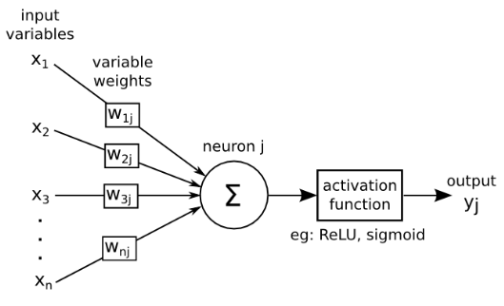

*Fig 5.Artificial Neuron Model (Andrew James)*

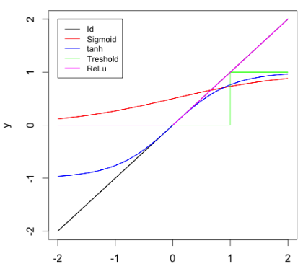

*Fig 6. Activation Function*

Historically, the sigmoid was the mostly used activation function since it is differentiable and allows to keep values in the interval [0,1]. Nevertheless, it is problematic since its gradient is very close to 0 when |x| is farther away 0.

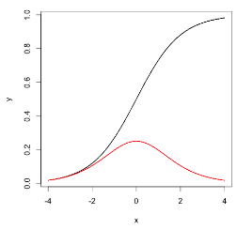

*Fig 7. Sigmoid function (black) and its derivative (red)*

Fig 7. represents the Sigmoid function and its derivative. With neural networks having a higher number of layers (which is the case for deep learning), this causes troubles for the back-propagation algorithm to estimate the parameter (back propagation is explained in the following). This is why the sigmoid function was supplanted by the rectified linear function. This function is not differentiable at 0 but in practice this is not really a problem since the probability to have an entry equal to 0 is generally null. The ReLU function also has a scarification effect. The ReLU function and its derivative are equal to 0 for negative values, and no information can be obtained in this case for such a unit, this is why it is advised to add a small positive bias to ensure that each unit is active. Several variations of the ReLU function are considered to make sure that all units have a non-zero gradient and that for x <0 the derivative is not equal to 0. Namely φ(x) = max(x,0) +α min (x,0) where α is either a fixed parameter set to a small positive value, or a parameter to estimate.

*B. Multilayer perceptron*

A multilayer perceptron (or neural network) is a structure composed by several hidden layers of neurons where the output of a neuron of a layer becomes the input of a neuron of the next layer. Moreover, the output of a neuron can also be the input of a neuron of the same layer or of neuron of previous layers (this is the case for recurrent neural networks). On the last layer, called output layer, we may apply a different activation function as for the hidden layers depending on the type of problems we have at hand: regression or classification. The Fig 8. represents a neural network with four input nodes, three output nodes, and two hidden nodes.

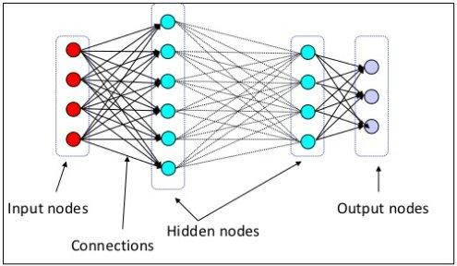

*Fig 8. A basic Neural Network*

Multi layers perceptions have a basic architecture since each unit (or neuron) of a layer is linked to all the units of the next layer but has no link with the neurons of the same layer. The parameters of the architecture are the number of hidden layers and number of neurons in each layer. The activation functions for each layer are subject to choice for every individual. For the output layer, as mentioned previously, the activation function is generally different from the one used on the hidden layers. In the case of regression, we apply no activation function on the output layer. For binary classification, the output gives a prediction of P (Y= 1/X); since this value is in [0,1], the sigmoid activation function is generally considered. For multi-class classification, the output layer contains one neuron per class, giving a prediction of P(Y = I/X). The sum of all these values has to be equal to1. The multidimensional function SoftMax is generally used as SoftMax.

σ(z)j =

Let us summarize the mathematical formulation of a multilayer perceptron with L hidden layers. We set h(0)(x) = x.

For k = 1 → L (hidden layers),

a(k)(x) = b(k) + W(k)h(k−1) (x)h(k)(x) = φ(a(k)(x))

For k = L+ 1(output layer),

a(k)(x) =b(k) + W(k)h(L)(x) h(L+1) (x) = ψ (a(k)(x)): = f(x, θ)

Where, φ is the activation function and ψ is the output layer activation function (for example SoftMax for multiclass classification). At each step, W(k) is a matrix with number of rows the number of neurons in the layer k and number of columns the number of neurons in the layer k−1.

*C. Back propagation Algorithms*

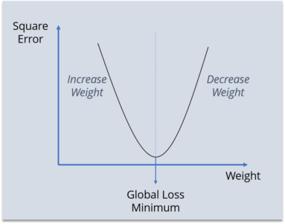 Backpropagation is a supervised learning algorithm, for training Multi-layer Perceptrons (Artificial Neural Networks). While designing a Neural Network, in the beginning, we initialize weights with some random values or any variable for that fact. The Backpropagation algorithm looks for the minimum value of the error function in weight space using a technique called the delta rule or gradient descent. The weights that minimize the error function is then considered to be a solution to the learning problem. Thus, the main aim for back propagation is to reach a Global Loss Minimum.

*D. Dataset, Pre-processing and Features*

The dataset contains a total of 3611 images. This is constituted by 911 healthy plants images, 890 having the Mosaic virus, 910 plants being infected by Rust and 900 samples of plants having Woolly aphids. Table 2 shows the composition of dataset of leaf images with class name and the number of plant leaf samples.

|  |  |
| --- | --- |
| **Image Class** | **Number of Samples** |
| Healthy | 411 |
| Mosaic virus | 360 |
| Rust | 431 |
| Woolly aphids | 474 |
| Total | 1676 |

*Table 2. Amount of data samples per class*

VI. Discussions and Results

The study was set out to classify if the crop is infected by a disease or is healthy. The DNN classifier used was fed with features (pixels of image instances). DNN classifier is used with 5 hidden units with 100 nodes each and a 6th hidden unit with 50 nodes. Figure 3. shows the Graphs of execution each hidden layer with a fraction of zero values (0-5 hidden layer) and figure 4. shows the histograms of each hidden layer with a fraction of zero values.

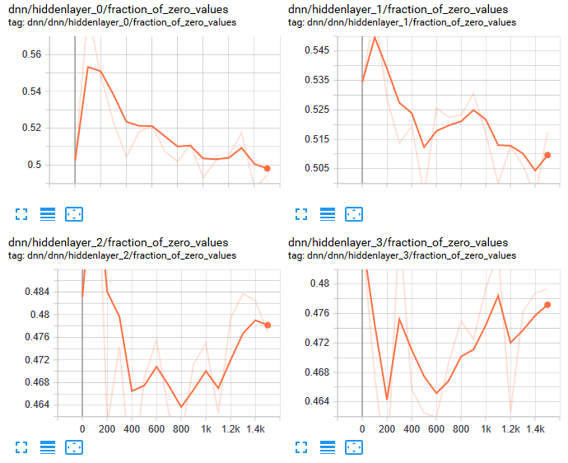

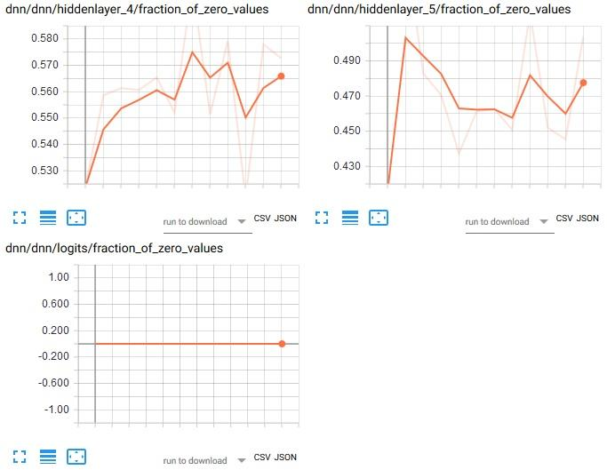

*Fig 9. Execution of different hidden layer with fraction of zero values.*

The images were pre-processed through resizing. The images with given height, width and channels are fed to the DNN. ReLU (Rectified Linear Unit) activation function was used.

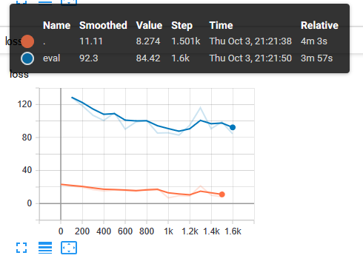

*Fig 11. Shows Line Plot of accuracy using Rectified Linear Activation function*

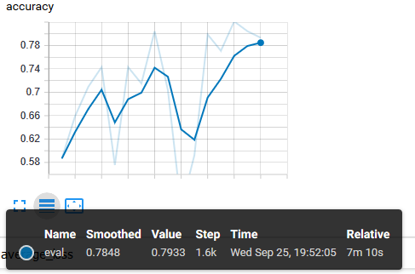

*Fig 12. Shows Line Plot of average loss using Rectified Linear Activation function*

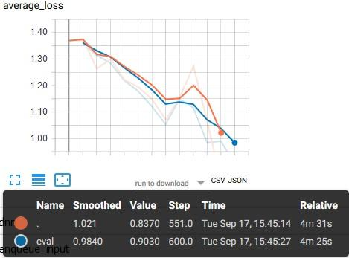

*Fig 11. Line Plot of average loss during training period*

Gradient descent algorithm is used as an optimization function to converge to the optimized classes quicker. The number of true values predicted correctly are represented as T, several false values predicted correctly are represented as F. The error was calculated using the error function mentioned.

$$Error = \left(\frac{F}{F+T}\right)* 100$$

VII. Conclusions and Future scope

In this paper, we have considered the cotton crop as it is the most important cash crop in India. Normally Orange rust, Mosaic virus, white woolly aphids are the hazardous diseases that the cotton crop suffers from in our country. Here, we consider Deep Neural Network for crop disease recognition using leaf images for classification. There are several methods in computer vision for plant disease detection and classification process, but still, this research field is lacking. At present, there are no commercial solutions available in the market dealing with plant disease recognition based on the leaf images. We use a new approach of deep learning which automatically classifies and detect crop diseases from leaf images.

The data set of size 1676 images is collected from my farm with different diseases. The crop leaf images are considered for the training and testing purpose of the network. Initially, with the use of Gradient Descent and Back-Propagation algorithm classification are performed and it gives the prediction of diseases with 79.53% efficiency.

Furthermore, Convolution Neural Network (CNN) can be used for better classification accuracy. The main aim is to detect the crop leaf diseases from the database and train the images in such a way that the trained model gives the solution to farmers. The proposed model can recognize 11 different types of plant diseases. Here we consider plant stream and affected area by the disease boundaries, colour variation, size and shape of plant leaves.

The future work of this project is to develop a complete system consisting of server-side components containing a trained model and an application for smart mobile devices with features such as displaying recognized diseases in plants, based on leaf images captured by the mobile phone camera. This application will serve as an aid to farmers, enabling fast and efficient recognition of plant diseases and facilitating the decision-making process when it comes to the use of chemical pesticides.

Acknowledgement

We wish to express our sincere gratitude to Dr. Sanjay U. Bokade, Principal and Dr. Satish Y. Ket, H.O.D of Computer Department of Rajiv Gandhi Institute of Technology for providing us an opportunity to do our project work on “Crop Disease Detection and Diagnosis System”. We sincerely thank our project guide Prof. Dilip S. Kale for his guidance and encouragement in carrying out this synopsis work.

References

1. Chopda, J., Raveshiya, H., Nakum, S. and Nakrani, V., 2018, January. Cotton Crop Disease Detection using Decision Tree Classifier. In 2018 International Conference on Smart City and Emerging Technology (ICSCET) (pp. 1-5). IEEE.
2. Kamble, J.K., 2018, February. Plant Disease Detector. In 2018 International Conference on Advances in Communication and Computing Technology (ICACCT) (pp. 97-101). IEEE.
3. Kulkarni, O., 2018, August. Crop Disease Detection Using Deep Learning. In 2018 Fourth International Conference on Computing Communication Control and Automation (ICCUBEA) (pp. 1-4). IEEE.
4. Mique Jr, E.L. and Palaoag, T.D., 2018, April. Rice Pest and Disease Detection Using Convolutional Neural Network. In Proceedings of the 2018 International Conference on Information Science and System (pp. 147-151). ACM.
5. Padol, P.B. and Yadav, A.A., 2016, June. SVM classifier based grape leaf disease detection. In 2016 Conference on advances in signal processing (CASP) (pp. 175-179). IEEE.
6. Petrellis, N., 2017, September. Mobile Application for Plant Disease Classification Based on Symptom Signatures. In Proceedings of the 21st Pan-Hellenic Conference on Informatics (p. 1). ACM.
7. Zeng, W., Li, M., Zhang, J., Chen, L., Fang, S. and Wang, J., 2018, October. High-Order Residual Convolutional Neural Network for Robust Crop Disease Recognition. In Proceedings of the 2nd International Conference on Computer Science and Application Engineering (p. 101). ACM.
8. Singh, V. and Misra, A.K., 2015, March. Detection of unhealthy region of plant leaves using image processing and genetic algorithm. In 2015 International Conference on Advances in Computer Engineering and Applications (pp. 1028-1032). IEEE.
9. Sardogan, M., Tuncer, A. and Ozen, Y., 2018, September. Plant leaf disease detection and classification based on CNN with LVQ algorithm. In 2018 3rd International Conference on Computer Science and Engineering (UBMK) (pp. 382-385). IEEE.